**Task**: design an algorithm for each of the following tasks in both ( pseudo code and flowchart )

1-reverse a string

A- get input for user

B- count length of string

C-create new list to hold reverse string

D- get the last character for string and make as first element in list

G- repeater step D the number of lengths of string

H- loop stope when new list hold with liters

K- display the reverse string.

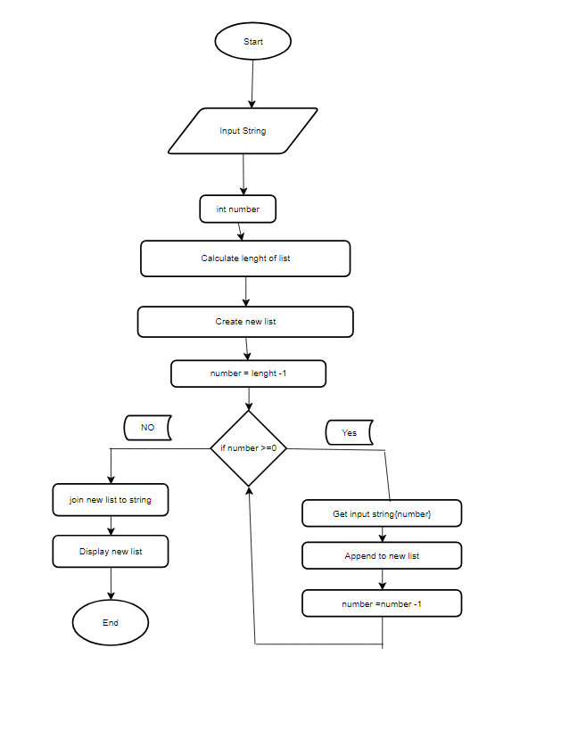

2-search in list of student marks for the highest one

A- input list of numbers

B- make first student make as highest one

C- comparting with second student marks

D- if first student marks is greater than second student marks

E - first student marks higher else second student marks has higher marks

L- repeater same process all students

K- display highest student mark

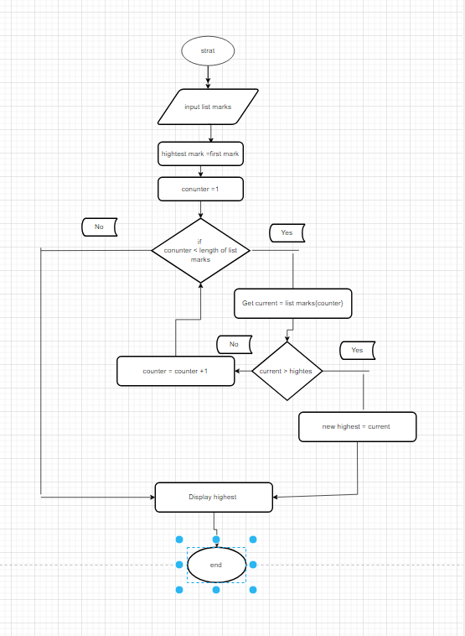

3-sort the students marks from highest to lowest

A- inputs students marks

B- store students marks in list

C- assuming first mark student is highest mark

D- than we Compare first mark with second mark

F- if first mark is greater than second mark swap between them

G- loop

S- display all student marks for highest to lowest

<https://stackoverflow.com/questions/44958483/sort-three-numbers-in-array-from-least-to-greatest>

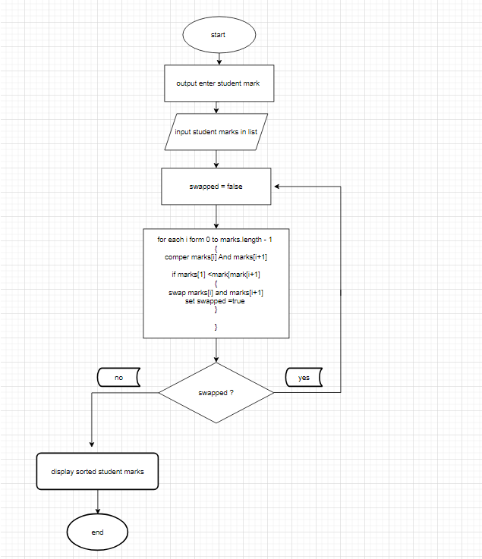

4-check if number is palindrome ( ex: 3443 is palindrome , 56 is not palindrome , 454 is palindrome )

A- input number

B- test if number is greater than 0

<https://www.programiz.com/c-programming/examples/palindrome-number>

